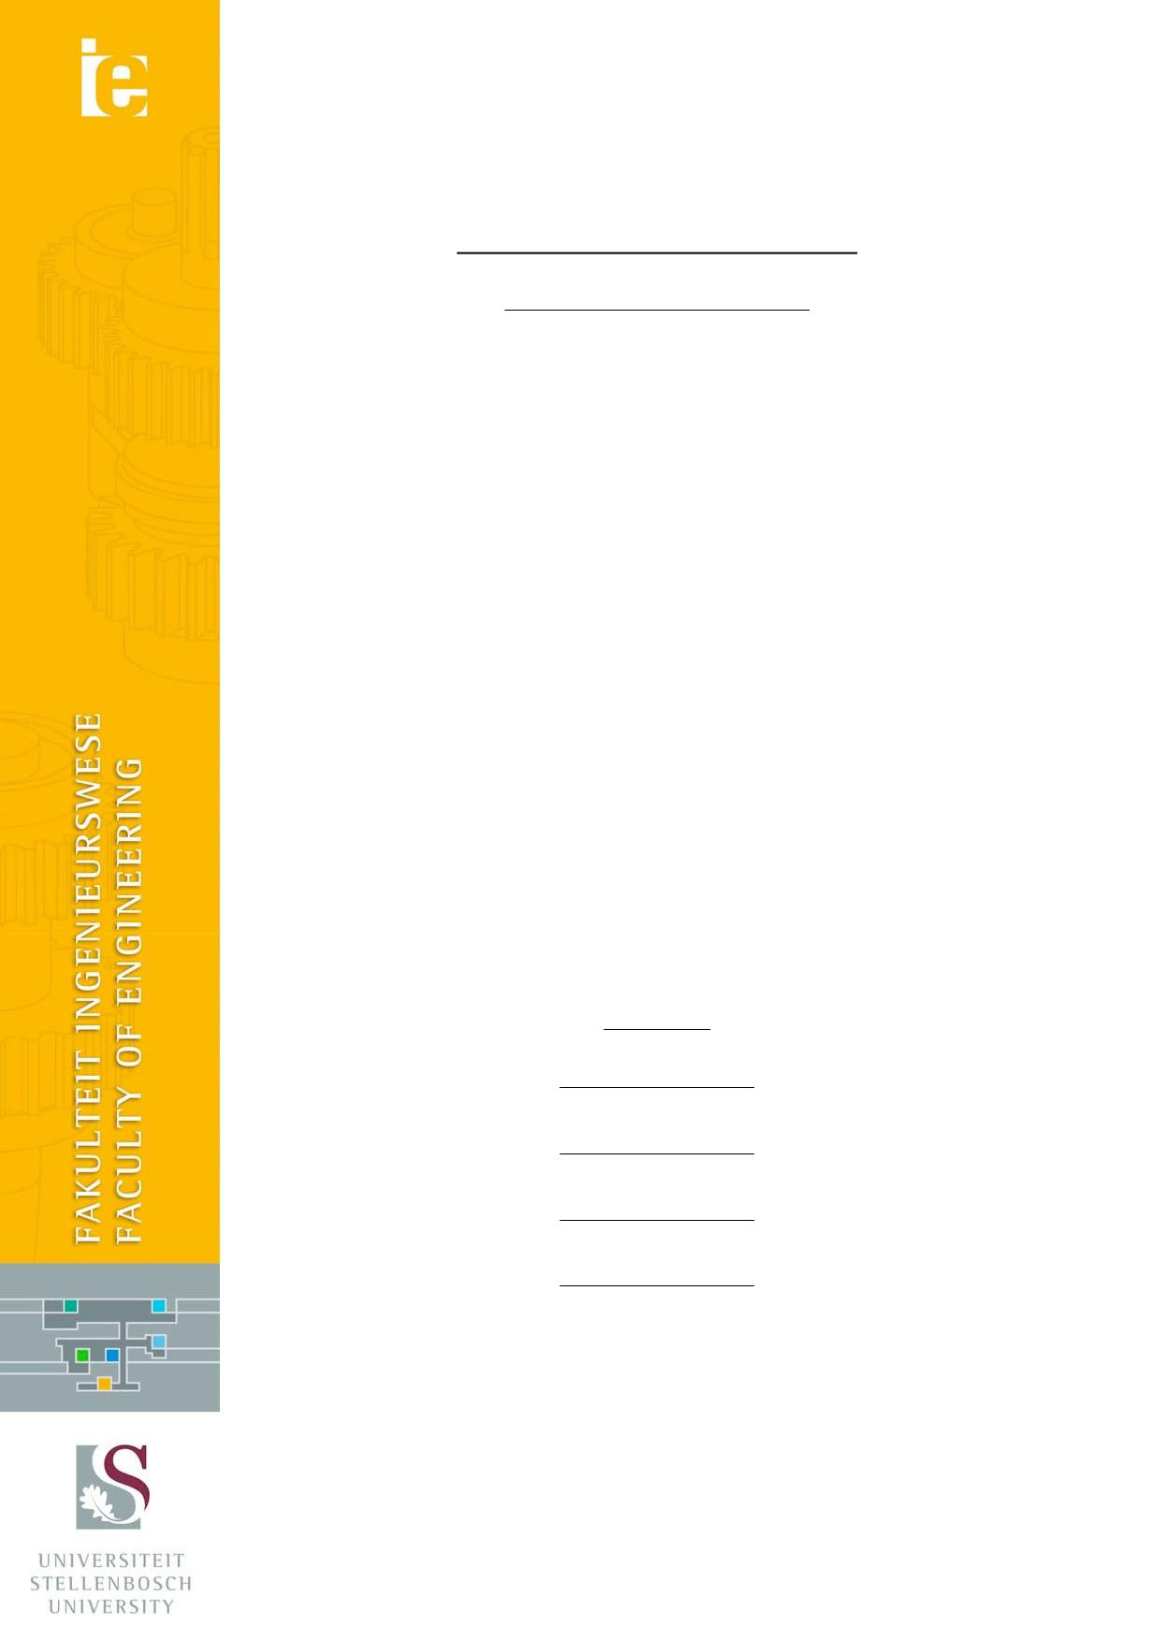

General Lab Safety Report

Student Safety Report

Date:
Student:
Lab Engineer:
Head of Safety: |  |  |  | Mr. C Zietsman
Lab Supervisor:
 |  | Emergency Contacts
 | Contact |  | Room nr. |  | Work nr. |  | Cell nr.
 | Lab Engineer
 | Lab supervisor
 | Mr. N Hlwempu |  | M141 |  |  |  | 083 735 6715
 | Mr. C Zietsman |  | M212 |  | 021 808 4275
 | Campus Security |  |  |  | 021 808 2333
 | Fire Brigade |  |  |  | 021 887 1333
 | Ambulance |  |  |  | 021 883 3444

Signatures

Operator:

COVID-19 Safety Procedures
The following additional safety procedures are required according to the SU COVID-19 Level 3 arrangements.
- A cloth facemask must be worn at all times on campus.
- Upon entering the building, the completed SU COVID-19 Employee Screening Questionnaire must be handed in to the staff member present at the entrance.
- Hands must be sanitised at the entrance.
- The student’s temperature must be recorded.
- If any of the answers to the questionnaire are “Yes” then the student is required to complete the Higher Health questionnaire. This can be done via WhatsApp.
- If a student exhibits symptoms (Any student with a recorded temperature of 37.5 °C or a moderate/high risk from the Higher Health check). M4000 will be used as a quarantine/waiting room, where Campus Health will advise how to proceed.
- The student may have to stay home until an isolation period has been completed.
- A social distance of 1.5 m must be maintained at all times.
- Hands must be personally sanitised regularly, and work surfaces must be thoroughly cleaned.

- Introduction

The purpose of this report is to outline the risks and mitigating actions associated with the testing that is to be performed as part of student projects. The general safety procedures for laboratory use will be outlined in this document.

- Warning Labels

Please be aware of the following warning labels, as seen below:
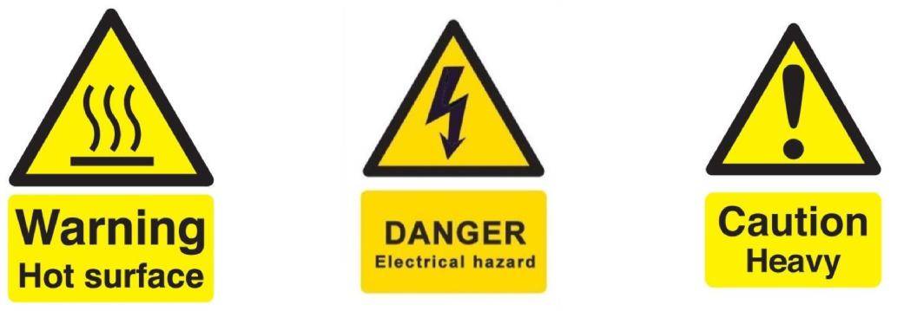

(a) Hot surface (b) Electrical hazard (c) Heavy object
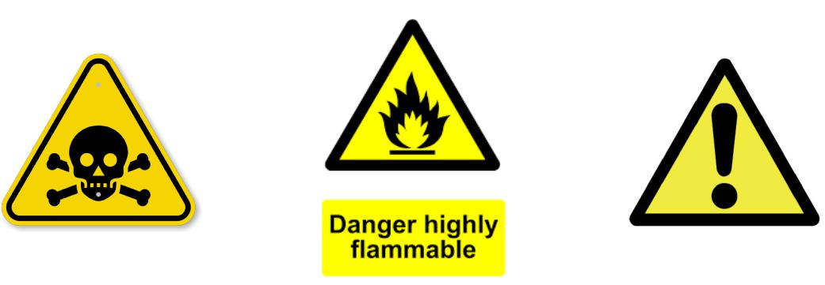

(d) Poisonous substance (f) General warning

(e) Flammable substance

Figure 1: Warning Labels

- General Lab Safety

- The following general lab safety instructions are applicable:
- No afterhours testing may be performed without the necessary permissions.
- An induction is required before testing may be undertaken.
- Closed shoes must be worn at all times.
- Emergency equipment must be located and easily accessible.
- Students may not work alone in the lab.
- Emergency exits must be known.
- Loose clothing may not be worn.
- Good housekeeping practices should be kept during testing.
- No food or drink is permitted in the lab.
- Safety report must be visible and accessible during testing.
- No equipment or test may be left unattended

- Anticipated Interactions with other Lab Users

The interaction with other lab users is anticipated to be minimal. Lab use is coordinated to prevent interference.

- General Housekeeping

- All equipment that has been used must be returned to its relevant storage on completion of the testing session.
- Any damage or equipment anomalies that are noted must be reported to the relevant responsible person. Please report if something goes wrong irrelevant of the cause as faulty equipment may lead to severe injuries of subsequent users.
- Do not leave specimens in the lab. Specimen quality will degrade and it is bad housekeeping. Storage solutions are provided in the form of sample cabinet.

